**Crewe & Chester Northern Services**

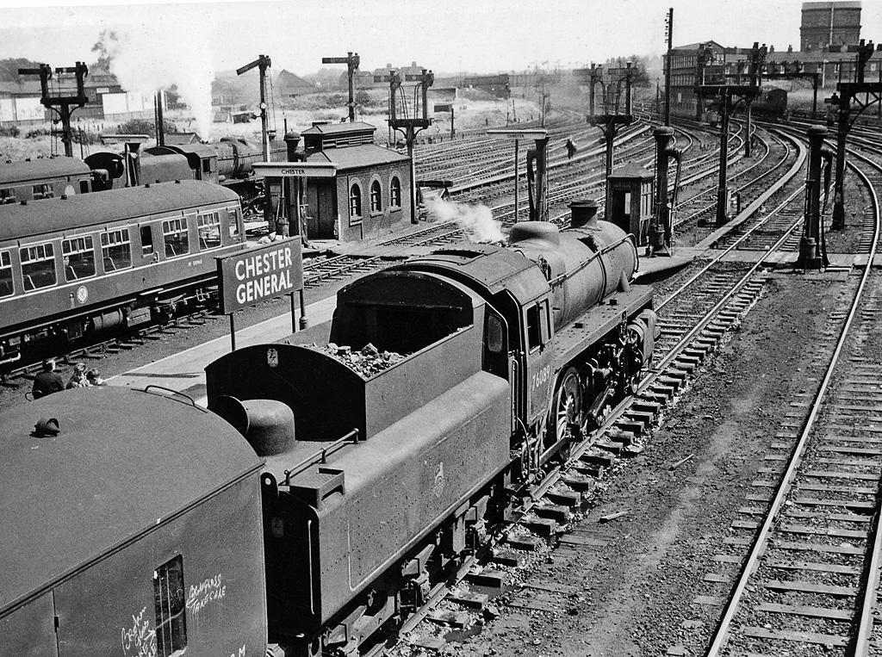

*Chester General Station in the good old steam days of 1962. The view faces east towards Crewe with the line branching left leading to Manchester.*

*From Wikipedia: Author Ben Brooksbank. Licensed under the Creative Commons Attribution Share-alike licence 2.0.*

**Simulation:**

This railway fills in the routes between existing northwest simulations - Crewe, Chester (Merseyrail), Liverpool Lime Street and Manchester Area. It is very heavily used by both passenger and freight services, the timetable covering a full eight-hour shift from 06:00 until 14:00 from the 2024 winter working timetable. After 14:00 services begin to dwindle and all are finished just before 15:05. Trains will be seen to move quite slowly as the area covers quite long distances, except within the Warrington and Stockport station areas.

**Operation:**

In this region there are many locations where paths cross other paths, so services shouldn't be routed too far ahead to avoid holding up other services. Waiting allowances are made in the timetable for faster services to take precedence, and often a service enters after another service but exits before it, so careful attention is needed to timings, especially exit times, to ensure that trains run in the intended order. Freight services in particular have very generous time allowances so these should be held back, sometimes for long periods, in favour of passenger services.

Several loops are provided to hold freight services so as to allow passenger services to pass and these have their own location names, so please check carefully which locations they are scheduled to serve. In particular don't confuse Warrington Goods with Warrington Bank Quay, Acton Bridge Loop with Acton Bridge, and Northwich Goods Loop with Northwich.

The pre-start session has routes set for the first minute of operation. Track cleaning train 3S06 follows closely behind freight 4M17 southwards towards Warrington Bank Quay, and that is the first to need a route setting when 4M17 has cleared the signal at 41-11. Although 3S06 runs westwards towards Chester it should wait for Liverpool to Chester service 1D00 as that exits before it.

**Acknowledgements:**

[TRAKSY.UK](https://traksy.uk/)

[RealTimeTrains](http://www.realtimetrains.co.uk/search/advanced)

[Open Train Times](https://www.opentraintimes.com/)

[OpenRailwayMap](https://www.openrailwaymap.org/)

[Network Rail North Western (North) Sectional Appendix](https://www.networkrail.co.uk/industry-and-commercial/information-for-operators/national-electronic-sectional-appendix/)

**************************